|  |  |
| --- | --- |
| **Name** | **Subashini S** |
| **Reg. No.** | **621421106050** |
| **Department** | **ECE** |
| **Year** | **III** |
| **College Name** | **Maha Barathi Engineering College** |
| **Group** | **IOT – Air quality monitoring** |

**Smart water fountains**

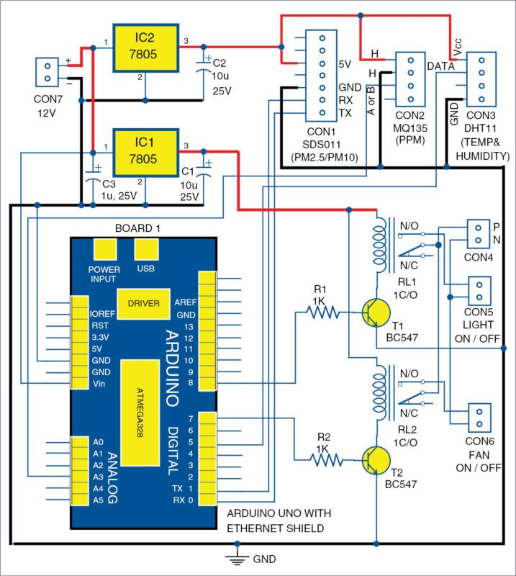

**Working**

IoT-based air quality monitoring systems work in a similar manner to noise pollution monitoring systems. Here is a general overview of how they operate:

1. Sensors: Air quality monitoring systems are equipped with sensors that measure various pollutants in the air, such as particulate matter, carbon dioxide, ozone, and volatile organic compounds (VOCs). These sensors can be placed in different locations to capture air quality data from multiple areas.

2. Connectivity: The monitoring system is connected to the internet through Wi-Fi or other communication protocols. This enables real-time transmission and reception of data.

3. Data collection: The sensors continuously collect air quality data, including pollutant levels and environmental conditions such as temperature and humidity. This data is then sent to a cloud-based platform for storage and analysis.

4. Cloud-based platform: The collected air quality data is stored and processed in a cloud-based platform. Advanced analytics algorithms can be applied to analyze the data and identify trends, patterns, and potential air pollution sources.

5. User interface: The monitoring system may have a user interface that displays real-time air quality information and provides access to historical data. Users can monitor air quality levels and identify areas with poor air quality.

6. Alerts and notifications: Based on predefined thresholds or user-defined criteria, the monitoring system can generate alerts and notifications when pollutant levels exceed certain limits. These alerts can be sent to relevant stakeholders, such as environmental agencies or facility managers, for further action.

7. Data visualization and reporting: The cloud-based platform can provide visualizations of air quality data through graphs, maps, and other visual representations. Reports can also be generated to provide insights on air pollution trends and support decision-making processes.

8. Integration with other systems: IoT-based air quality monitoring systems can be integrated with other systems, such as smart city platforms or health monitoring systems. This integration allows for a comprehensive approach to managing air pollution and enables coordinated actions across different domains.

By utilizing IoT technology, air quality monitoring systems provide valuable information on the quality of the air we breathe, helping to identify pollution sources and implement measures to improve air quality and protect public health.